Name:Mahathi Kurapati
Email:kurapati.mahathi@gmail.com
Task1: Screenshots Steps of hosting task tracker in AWS
Step 1: creation of s3 bucket and static website hosting:
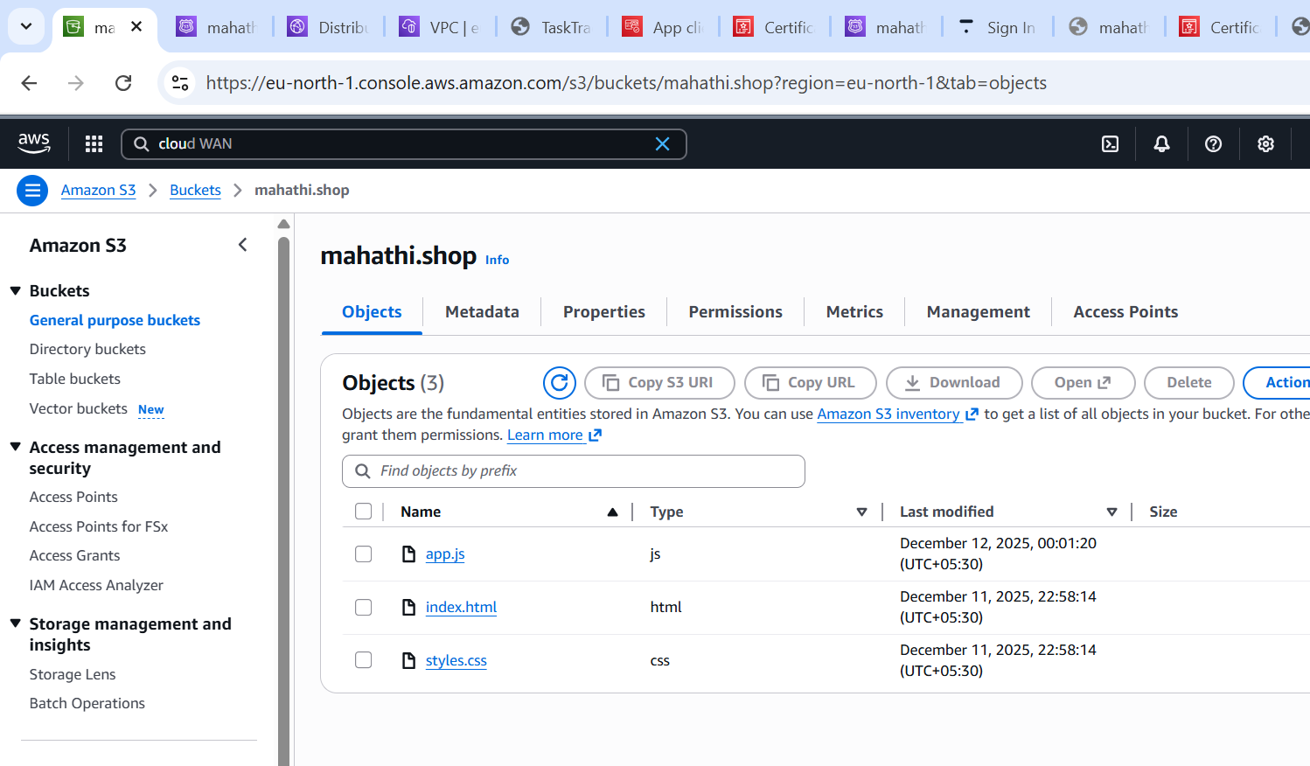
Step 2: link of static website :
http://mahathi.shop.s3-website.eu-north-1.amazonaws.com

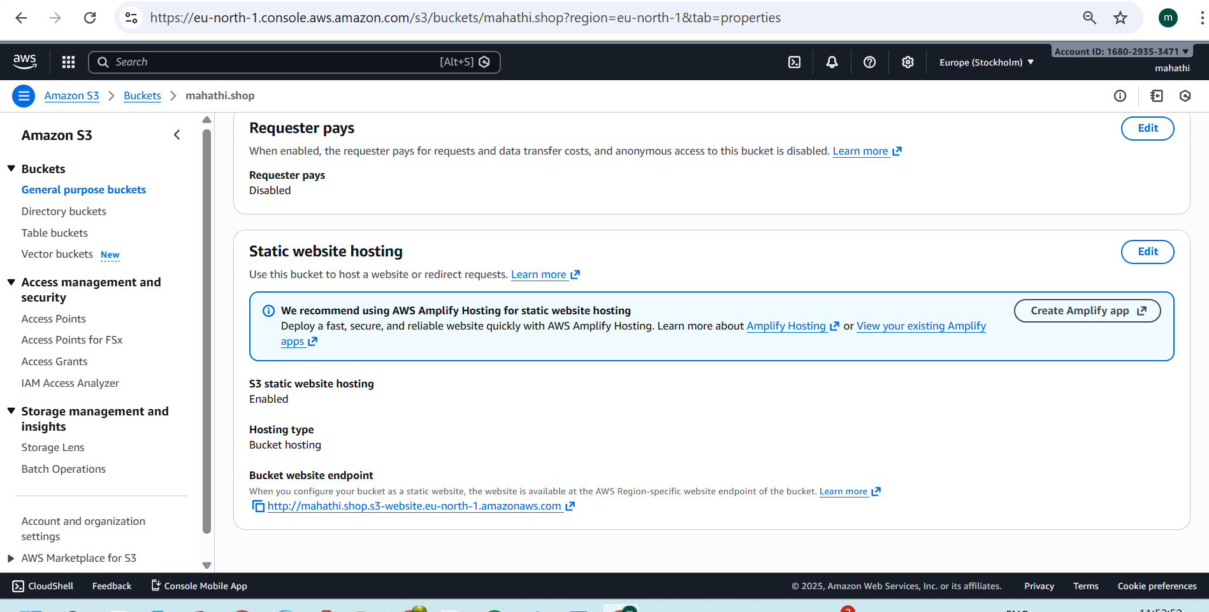
Step 3: AWS Cognito configuration
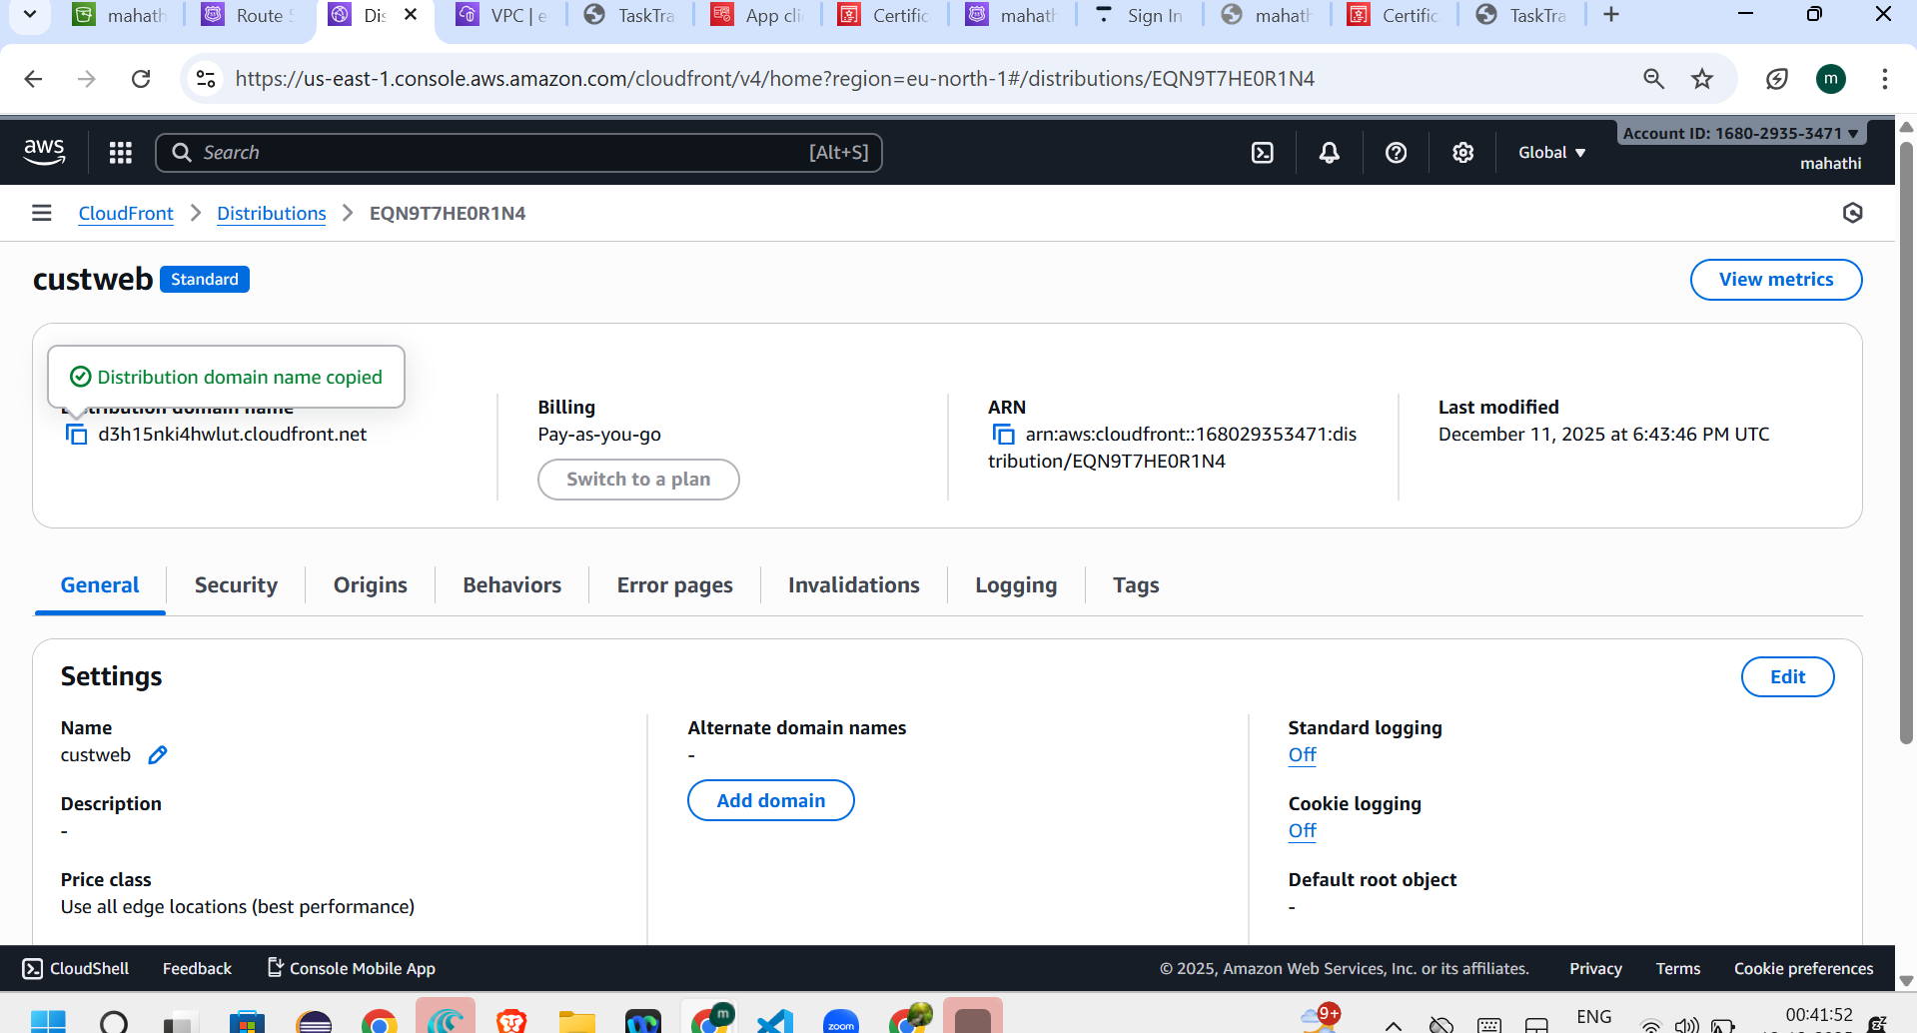
Step 4: final website published on my own domain
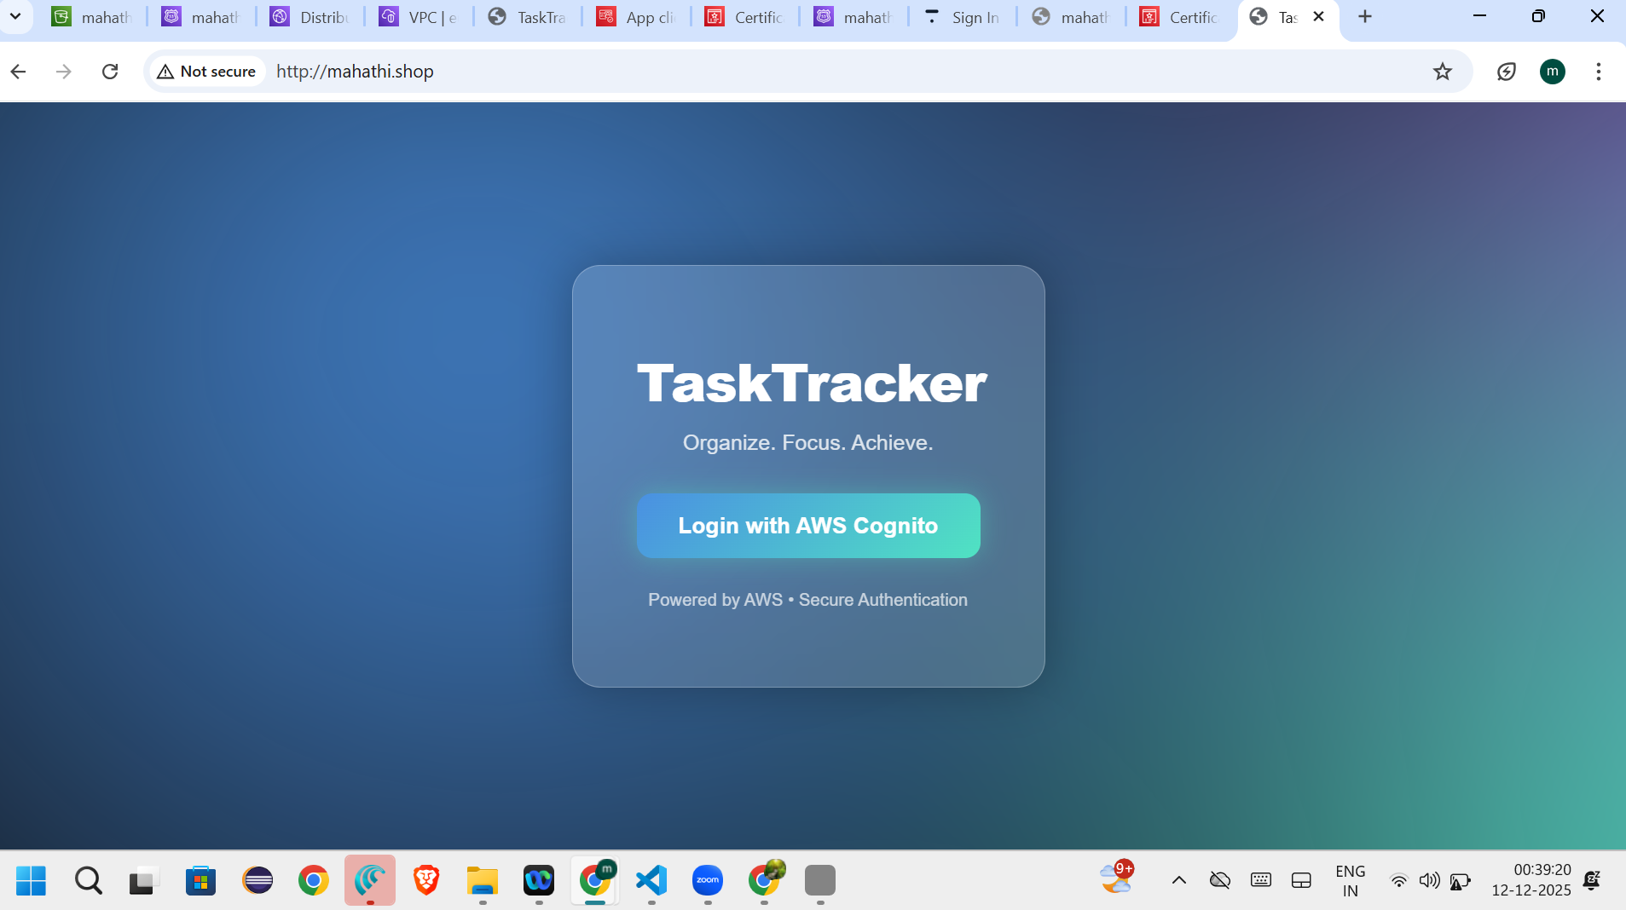
TASK-2:Amazon Bedrock
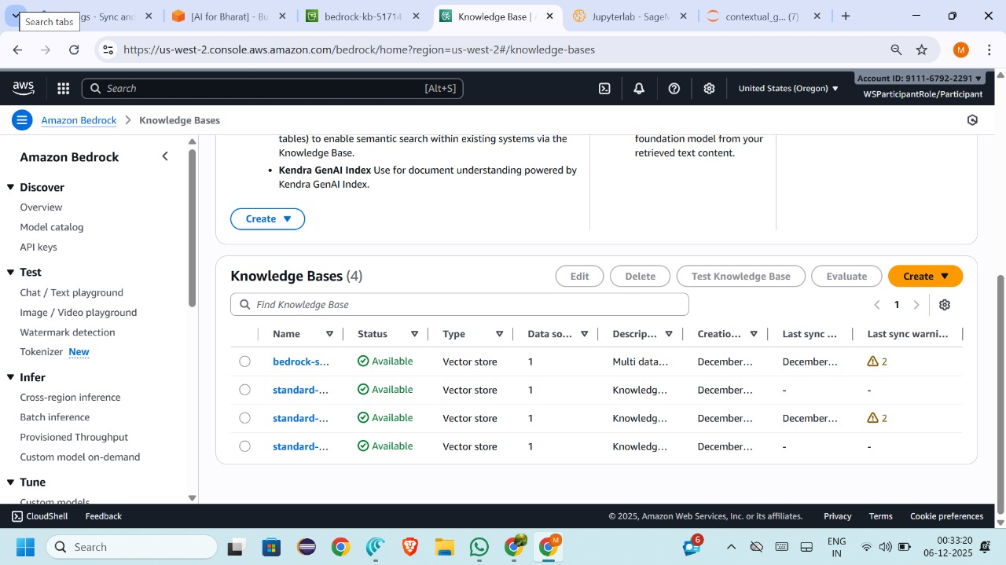

Task-3:Rds
Step 1: Creating the RDS MySQL Instance (AWS Console)I logged in to the AWS Management Console and navigated to Amazon RDS.
From the RDS dashboard, I clicked on Create database and selected Standard Create.
- Database Engine: MySQL
- Engine Version: Default (AWS recommended)
- DB Instance Identifier: user-defined
- Master Username: admin
- Authentication Method: Password authentication
I selected the Free Tier option and configured:
- Instance class: db.t3.micro
- Storage type: General Purpose (SSD)
- Allocated storage: 20 GB
For connectivity:
- Public access: Yes
- VPC security group: Allowed MySQL/Aurora (Port 3306) from my IP address

Step 2: Connecting RDS Using MySQL Client (Hands-On):I opened MySQL Client / MySQL Workbench on my local system.as below image I provide
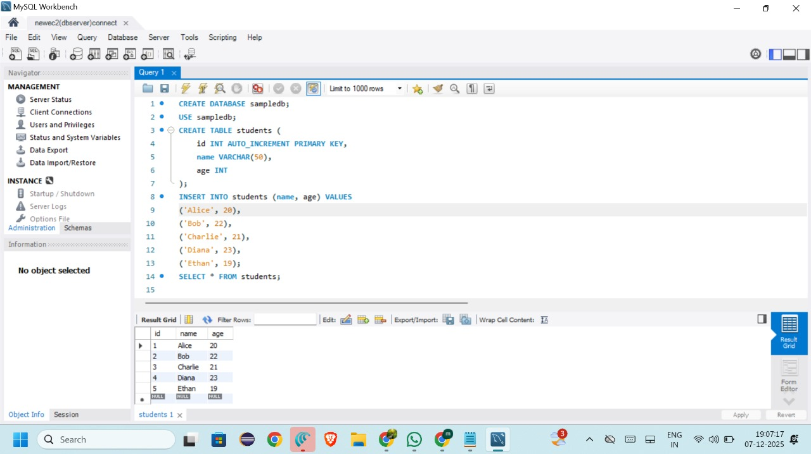

Connecting Amazon RDS MySQL Using EC2 Instance (AWS Console – Hands-On)

Step 1: Connecting to EC2 Instance Using EC2 Instance Connect
I logged in to the AWS Management Console and navigated to EC2 → Instances.
I selected my running EC2 instance and clicked Connect.
Using EC2 Instance Connect, I successfully accessed the Linux terminal of the EC2 instance through the browser.

Step 2: Accessing MySQL from EC2
Inside the EC2 terminal, I connected to the Amazon RDS MySQL database using the MySQL client by providing the RDS endpoint, username, and password.
After successful authentication, the MySQL prompt appeared, confirming that the EC2 instance was connected to the RDS MySQL server.
Step 3: Verifying Database Connection

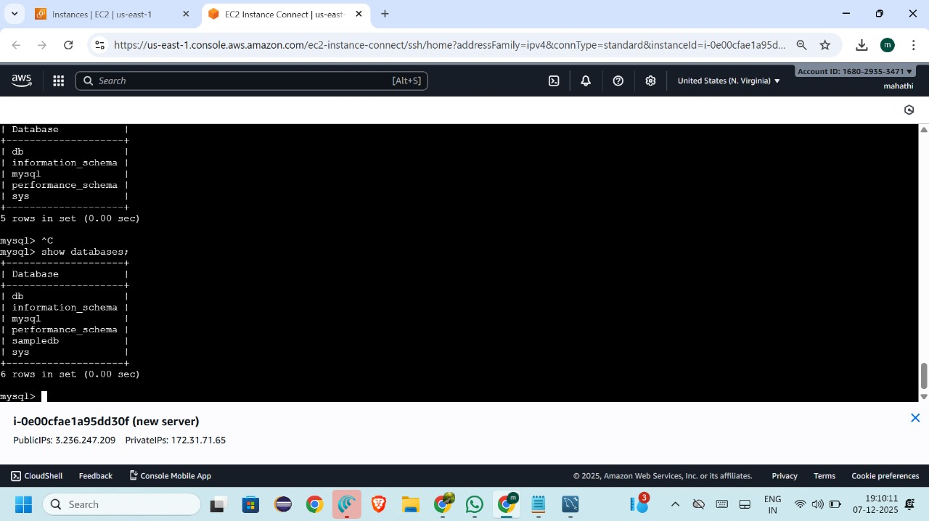
Task 4:Route53

Step 1: Purchasing the Domain
I purchased a custom domain name from a domain registrar.
After completing the purchase, the domain became active and ready for DNS configuration.

Step 2: Adding and Updating Name Servers
After purchasing the domain, I accessed the DNS / Nameserver settings of the domain.
I replaced the default name servers with the required custom name servers provided by the hosting / cloud platform.
Once the name servers were updated, I saved the changes and waited for DNS propagation, which may take some time to reflect globally.

Step 3: Connecting the Domain to the Hosting Environment
After the name servers were successfully propagated, I connected the domain to my application’s hosting environment by configuring the required DNS records.
This ensured that the domain correctly pointed to the server where the application was hosted.

Step 4: Deploying the Application
Once the domain connection was successful, I deployed the application to the server.
After deployment, I verified that the application was accessible through the custom domain URL in a web browser.
The application loaded successfully
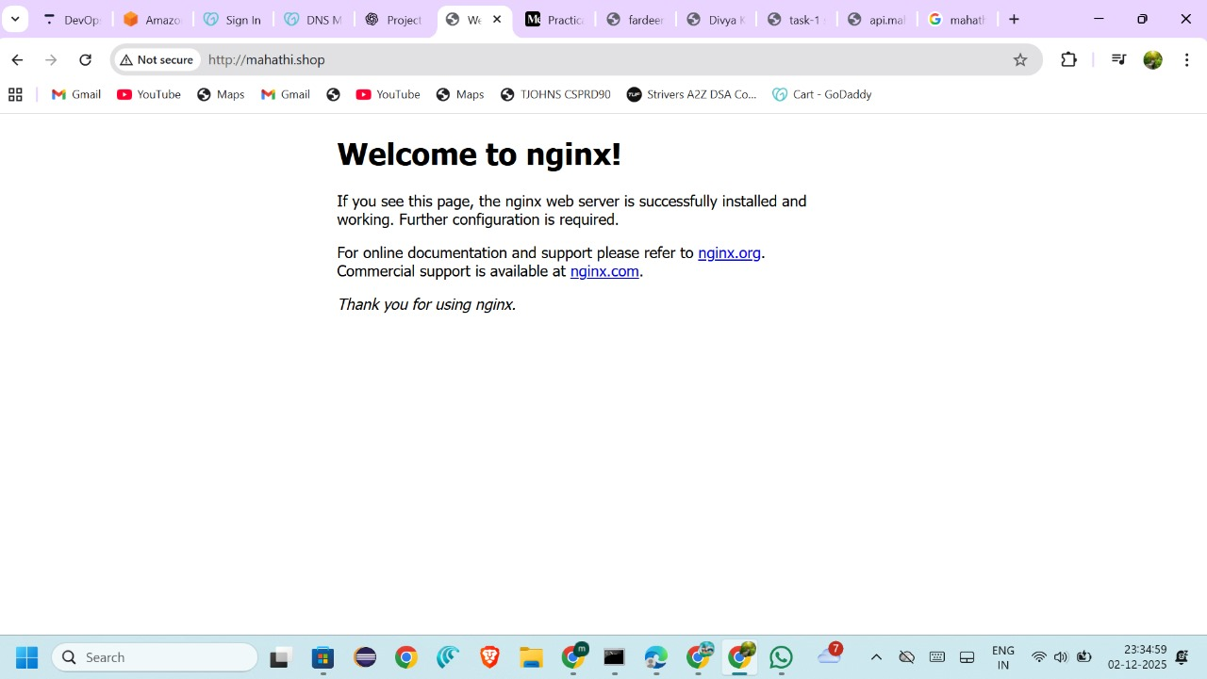

Task 5: Secure Web Application Deployment on AWS Using VPC, Public & Private Subnets, NAT Gateway, Bastion Host, and Auto Scaling
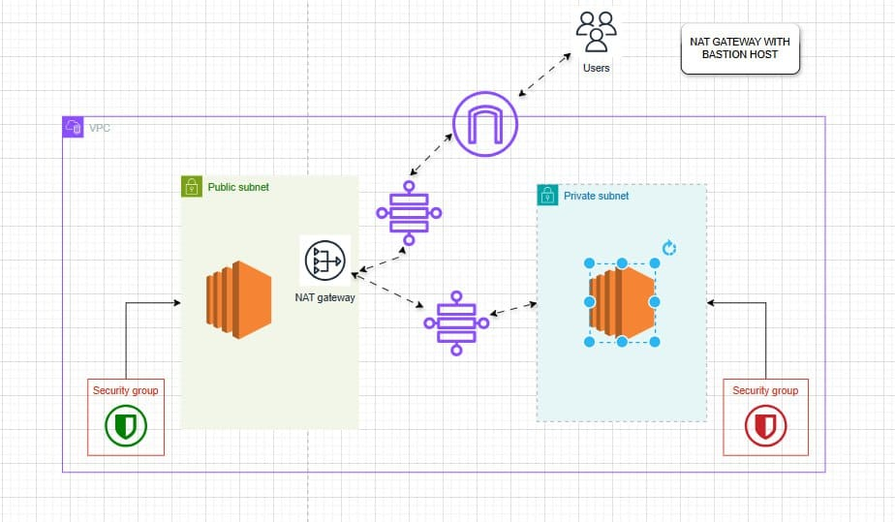
The application was deployed using a secure AWS VPC architecture consisting of:
- One Virtual Private Cloud (VPC)
- Public Subnet (Bastion / Web Server)
- Private Subnet (Application Server)
- NAT Gateway for outbound internet access
- Security Groups for access control
- Domain Name mapped to the public server
This architecture ensures security, scalability, and controlled access.

2. VPC and Subnet Configuration
A custom VPC was created with two subnets:

Public Subnet
- Hosted the public EC2 instance
- Contained:
  - Bastion Host
  - NAT Gateway
- Allowed inbound traffic from the internet
- Used for SSH access and web access

Private Subnet
- Hosted the private EC2 instance
- No direct internet access
- Outbound internet access enabled only via NAT Gateway
- Improved security for backend resources

3. Bastion Host & NAT Gateway Setup
A Bastion Host was launched in the public subnet to securely access private instances.
A NAT Gateway was configured in the public subnet to allow the private EC2 instance to:
- Download updates
- Access external services (e.g., Google)
The route tables were configured so that:
- Public subnet → Internet Gateway
- Private subnet → NAT Gateway

4. Connecting to Private EC2 via Bastion Host

SSH Access Flow
- Connected to the public EC2 (Bastion Host) using EC2 Instance Connect

5. Verifying Internet Access from Private Subnet
From the private EC2 instance, internet connectivity was verified

Screenshots as below:
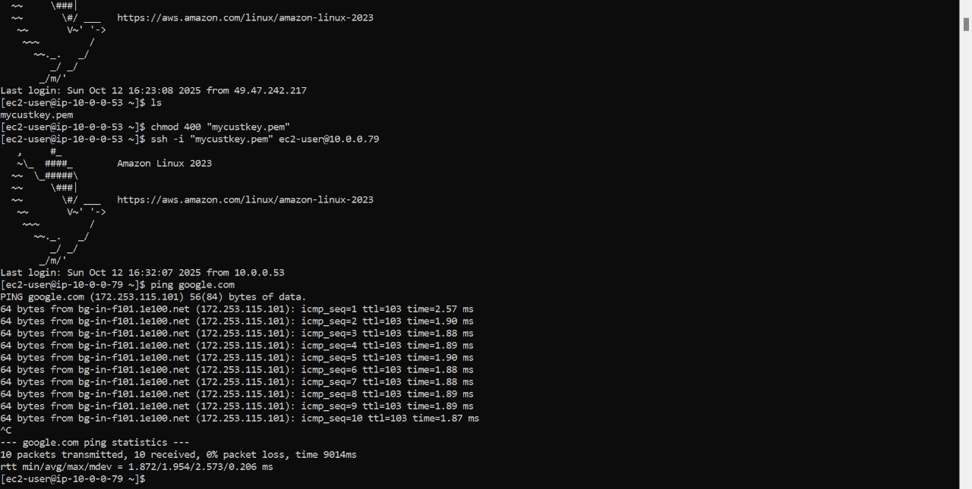

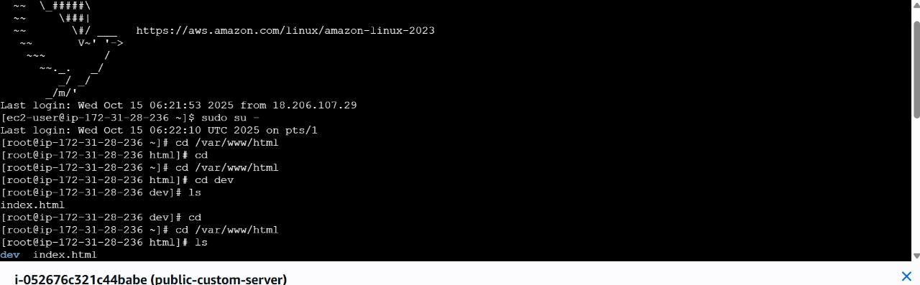
Task 6: AUTOSCALING:
Auto Scaling in AWS is used to automatically manage the number of EC2 instances based on demand. It improves availability, fault tolerance, and scalability by launching or terminating instances as required.

Auto Scaling Group Creation
An Auto Scaling Group (ASG) was created using a predefined Launch Template that contained:
- Amazon Linux 2023 AMI
- Instance type configuration
- Security group settings
- Key pair for SSH access
The Auto Scaling Group was associated with the VPC and the required subnets.

Desired Capacity Configuration
Initially, the desired capacity of the Auto Scaling Group was set to 0.
Later, the desired capacity was increased to 1, triggering the Auto Scaling mechanism.

Automatic EC2 Instance Launch
When the desired capacity was changed from 0 to 1, AWS automatically launched a new EC2 instance.
From the Activity History:
- Auto Scaling detected a difference between desired and actual capacity
- A new EC2 instance was launched successfully
- The instance status changed to Running
This confirms that Auto Scaling was functioning correctly.
Health checks are done regularly,if a server is unhealthy immediately an other server is created using auto scaling group
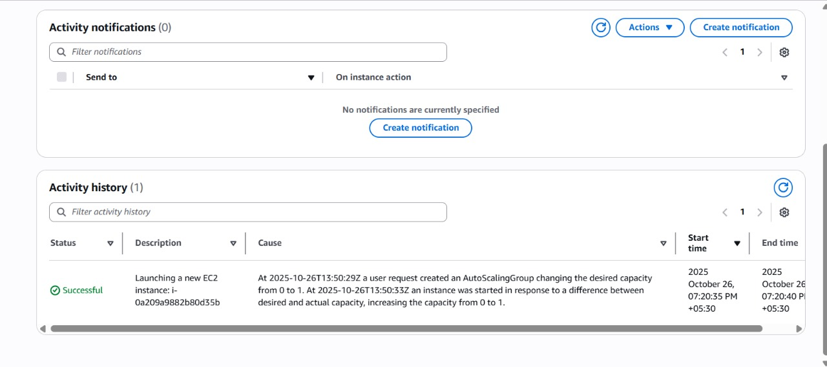
Task 7: Project deployed on multi-AZ and Deployment on AWS Using VPC, Public & Private Subnets, NAT Gateway, Bastion Host, and Auto Scaling :
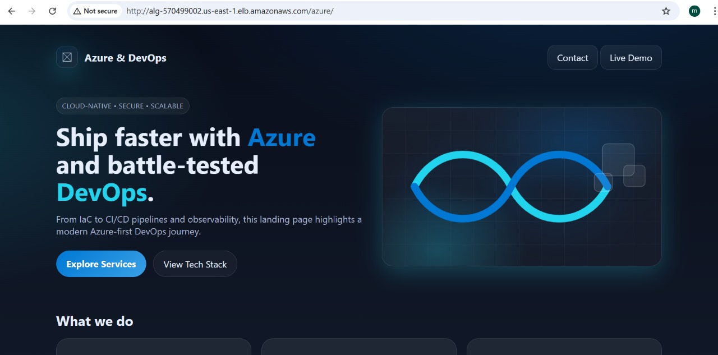
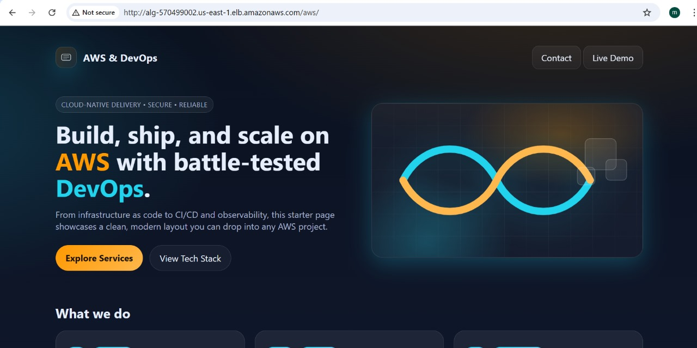
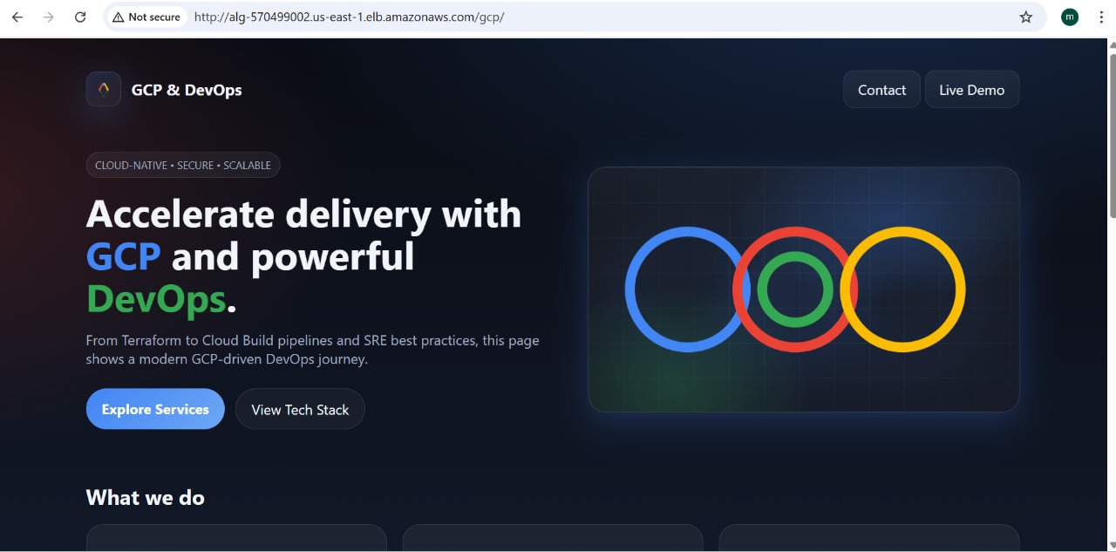
Task 8: Creation of IAM:
